# Simulator User Manual for P2

CSCI 6461 Group 1 (2019 Fall)

1. **The User Interface**

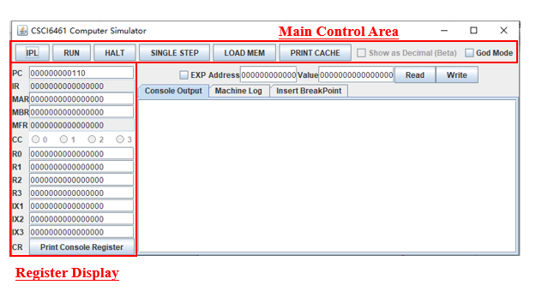

Figure 1: The User Interface of the simulator

Figure 1 shows the simulator GUI interface.

**Main Control Area**

* **IPL Button** will reset the entire simulator. All data inside the memory and registers will be set to initial value.
* **Run Button** will continue to execute instruction driven by PC unless it meets a HALT instruction or manually click the HALT button on the GUI.
* **HALT Button** will send a HALT.
* **SINGLE STEP Button** will execute one instruction from the PC.
* **LOAD MEM Button** will read a CSV file and load the value to the memory.

The CSV file should have 2 fields.

<Memory Location(Binary String)>,<Data(Binary String)>.

Here is an example:

000000000001,0000011100011111

000000000010,0000011100011111

000000000011,0000011100011111

000000000100,0000011100011111

The example above load data "0000011100011111" to memory location 01,10,11,100.

* **PRINT CACHE Button** will print the entire cache data to the “Machine Log” Output Space.

**Register Field**

* Most of the register value is editable, while some of the registers like IR, MFR, CC is not changeable.
* To change the value of the register, type the value you want to set and press <Enter>.
* **Print Console Register Button** will print all the console register data to the “Machine Log” Output Space. (Console Register is used for IN/OUT Instruction, with DEVID 3-31).

**Memory Field**

* EXP Click-box is the Memory Expand button. When this box is checked, the max memory is set to 4096 words, while the default is 2048 words.
* To read the memory value, just type the address you want to read, click the Read button, and the value will appear on the value field.
* To write the memory, just type the address and the value and click Write button. If your input is legit, the value will be writing to the memory location.

**Console Output**

* This is the place for the OUT Instruction to print something. This simulates the “Console Printer” for OUT Instruction.

**Machine Log**

* This is the place to display all the machine logs, which have a very specific detail to demonstrate what the simulator is doing.

You can check whether the Cache is HIT or MISS, the value of all dumped info, etc.

**Insert BreakPoint (DEBUG ONLY)**

* This is the place to set a breakpoint. When clicking the RUN button, when PC meets any of the breakpoint values, the simulator will come to a stop so you can start single step for easy debugging.

1. **Operate the simulator to Testing Program 2**

A program that reads a set of a paragraph of 6 sentences from a file into memory. It prints the sentences on the console printer. It then asks the user for a word. It searches the paragraph to see if it contains the word. If so, it prints out the word, the sentence number, and the word number in the sentence.

**To run this testing program, follow the step below:**

* Open the simulator JAR file, and click the “IPL” Button.
* Click the “LOAD MEM” Button, and select the testing program 2 CSV file. (File Name: TestingProgram3(P3).csv )
* Click “RUN”
* It will require load default paragraph here we have example txt file named TestProgram2-Paragraph.txt .
* Then it will ask for a user input word to search. If it find the word, it will print out sentences number and word number of sentence. Else, print nothing but the paragraph